Photo Uploader

Author: Lawrence Botley  
Last modified: 07/11/2007

1. Overview
2. The interface and functionality  
   2.2 Loading the Silverlight application  
   2.3 Selecting a folder  
   2.4 Creating a new folder  
   2.6 Selecting a local disk directory  
   2.7 Uploading Images  
   2.8 Deleting photos  
   2.9 Rotating photos
3. Web services

2.1 Create new Collection Folder

2.2 Get all collections

2.3 Gets the photo URLS for a collection

2.4 Upload photos to the Next2Friends folder

2.4 Delete photos from the Next2Friends folder

**1. Overview**

The photo uploader allows members to select photos to upload from both their local disk and their mobile device. This phase will only include the implementation for local disk upload but device should also be considered throughout design.

The user flow will be as follows

1. PhotoUploader page loads
2. The user selects the source location.( Mobile device or Local disk)
3. Local disk is selected and a tree control allows the user to see the directory structure of their computer
4. Once a directory is selected a section of the page is populated with the images from that directory
5. The user then chooses the library collection on Next2Friends to add the photos to
6. The user can now drag and drop the photos into the folder. As soon as the drag event has been fired, the images are uploaded.
7. The user finishes uploading and moves to another page

**2.0 The interface and functionality**

2.1 The Silverlight application should have a button to toggle the application between:

* Normal size (900px width, 700px (or more) height). This when the application is embedded into the web page
* Full browser screen
* Full-screen

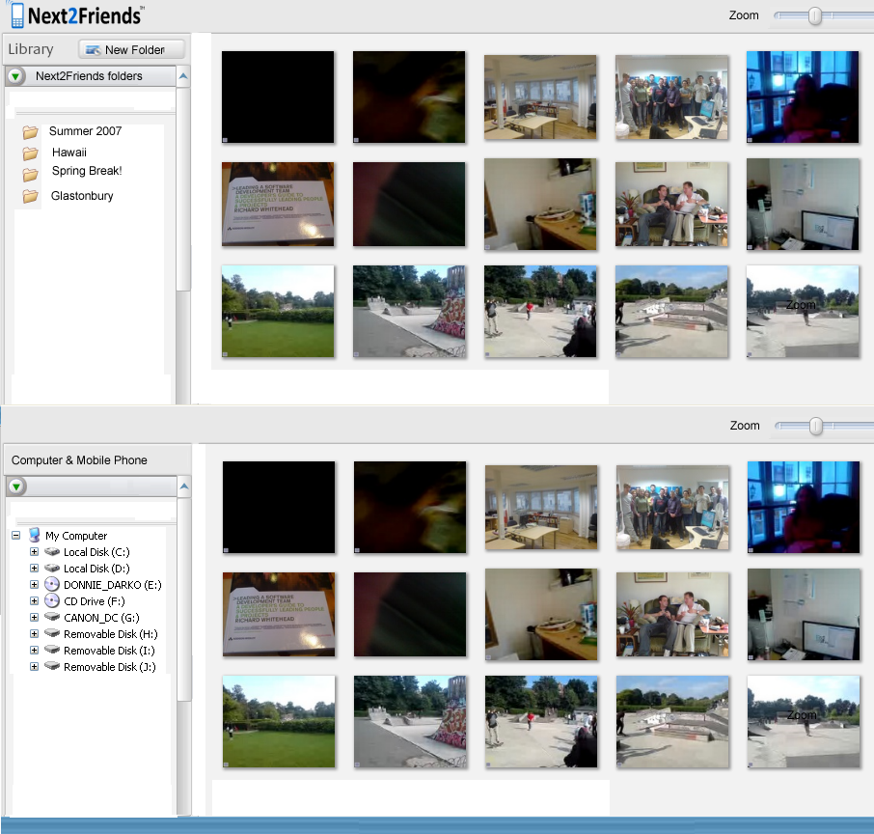

Draggable splitter control

Photos Currently on Next2Friends in the selected collection. Gets the current photos via a web service call (3.3)

Library of photo Collections . Gets the list of collections via a web service call (3.2)

Creates a new collection folder on Next2Freinds using a web service call (3.1)

Zoom the Next2Friends view thumbnails

Zoom the computer view thumbnails

Photos from currently selected local directory

Directory browser for local disk and mobile phone

**User driven events**

**2.2 Loading the Silverlight application**

1. Call the CreateCollections() web service method and return all the collection names from Next2Friends
2. Populate the left folder list with the folder names
3. The local file directory tree is also populated with drives letters obtained using System.IO GetDirectory() calls

**2.3 Selecting a folder**

1. User clicks on a folder
2. the web service method GetCollections() is called passing the Directory ID as a parameter
3. The image URLs for that collection are returned. They are then placed in the adjacent window.
4. Photo can be dynamically resized in the display with the zoom control. The zoom only resizes for better visibility.

**2.4 Creating a new folder**

1. The user clicks on the new folder button
2. A popup asks the user the name of the folder they wish to create
3. The web service method CreateNewCollection() is called and the name is passed as a parameter
4. If the folder was created successfully, true will be returned and the folder is added to the Collection list
5. If false is returned from the web service a friendly error message is given

**2.6 Selecting a local disk directory**

1. User clicks on a directory to open it
2. System.IO.GetFiles() is called on the directory and all Image files are returned as fileinfos
3. Each of the fileInfo objects are converted into image bitmaps
4. The right adjacent photo browser window is then populated with thumbnails of all the photos in that directory
5. Photo can be dynamically resized in the display with the zoom control. The zoom only resizes for better visibility.

**2.7 Uploading Images**

1. The user selects one or more photos in the local disk area browser by either single click or multiple select via mouse drag
2. The user drags a file from the bottom window (local disk) to the top window.
3. The drag event is fired
4. All the selected photos are resized to a 800x600
5. The photos are uploaded one by one by calling the UploadPhoto() web service method

**2.8 Deleting photos**

It is possible to delete a photo from a collection on the Next2Friends Server

1. Select one or more photos clicking the mouse on a photo (or dragging over multiple photos)
2. Click the delete button on the top
3. Confirm the delete via a popup
4. Call the DeletePhoto() web service method for each photo specifiying the file Guid
5. If the call returns true then update the folder photo view by removing it

**2.9 Rotating photos**

When a user clicks on a photo inside the local disk control it should zoom and move so the user can better view it.The image thumbnail should also have two small buttons in the bottom right to rotate the image either right or left.

When the image is rotated:

1. Actual image file on disk is opened
2. rotated 45 degrees in that direction
3. Saved back to disk
4. Update the thumbnail in the Silverlight application

Note: rotate is for local files only. Users cannot yet rotate the image once it has been uploaded to the server

**3.0 Web services**

The ValidationToken is a 128 bit Guid converted to a base64 string and is obtained from the html as a parameter. This could be a JavaScript variable or any other suitable method.

The member ID is also a base64 guid string.

**2.1 Create new Collection Folder**

CreateNewCollection(string MemberID, Guid ValidationToken as Base64string)

Returns a Boolean value denoting if the collection was successfully created

**2.2 Get all collections**

GetCollections(string MemberID, Guid ValidationToken as Base64string)

Returns a datastructure containing the name as a string and a base64 guid denoting the directoryID

**2.3 Gets the photo URLS for a collection**

GetPhotosByCollection(string MemberID, Guid ValidationToken as Base64string)

Returns an array of datastructures containing the URL of the photo and a base64 guid denoting the WebPhotoID

**2.4 Upload photos to the Next2Friends folder**

UploadPhoto(string MemberID, Guid ValidationToken as Base64string, byte[] PhotoData)

Returns true if upload was successful

**2.4 Delete photos from the Next2Friends folder**

DeletePhoto(string MemberID, Guid ValidationToken as Base64string, byte[] PhotoData)

Returns true if upload was successfully deleted

The details of the web services including location and WSDL will be given in the next few days